|  |  |
| --- | --- |
| C:\Users\Plasma-PC\Desktop\logo.jpg | **MINISTRY OF EDUCATION AND TRAINING** |

**FPT UNIVERSITY**

**Capstone Project Document**

**Olives**

Project Code: Olives  
Document Code: **Olives_PP_v1.0**

|  |  |  |
| --- | --- | --- |
| **Olives Team** | | |
| **Group member** | Phạm Đức Thắng | SE03055 |
| Trần Ánh Dương | SE02797 |
| Phạm Minh Tuấn | SE02875 |
| Bùi Quốc Trọng | SE03418 |
| Nguyễn Văn Hưng | SE02582 |
| Nguyễn Duy Linh | SE03150 |
| **Supervisor** | Lecturer: Phan Trường Lâm | |
| **Capstone Project code** | Olives | |

**Hoa Lac, 18th May 2016**

**CONTENT**

**1.** **Problem Definition** 2

1.1 Name of this Capstone Project 3

1.2 Problem Abstract 3

1.3 Project Overview 3

1.3.1 The Current System 3

1.3.2 The Proposed System 3

1.3.3 Boundaries of the System 3

1.3.4 Development Environment 3

**2.** **Project organization** 4

2.1 Software Process Model 4

2.2 Roles and Responsibilities 5

**3.** **Project Management Plan** 6

**3.1** **Task** 6

**3.2** **Project Schedule** 6

**3.3** **Meeting Minutes** 6

**4.** **Resource** 6

**5.** **Risk Management** 6

**6.** **Communication Management** 6

**9.** **Project Infrastructure** 8

9.1 Software and Techniques 8

9.2 Hardware 9

9.3 Other Infrastructure 9

**10.** **Coding convention** 9

**11.** **Version Numbering Rule** 9

**12.** **Directory Structure** 10

**13.** **Other Olives Rules** 11

1. Introduction

## Purpose

The purpose of MT Screen Design Document is to provide User Interface and Screen Flow of the project call Olives, which is an application that helps people take care your helps. Developer and tester will base on this design to implement and unit test.

## Definitions, Acronyms, and Abbreviations

|  |  |  |
| --- | --- | --- |
| Abbreviations | Description | Comment |
|  |  | Name of project |

## References

|  |  |
| --- | --- |
| Document Number | Title |
| 1 | Data design document |
| 2 | Architecture design document |

## Overview

This document include

* • Introduction of MT Project’s Screen Design.
* • Screen flow and some more detail description’s screen.

# User Interface design

2.1 Patient Application

## 2.1 Main Application

### 2.1.1 Create Account Screen

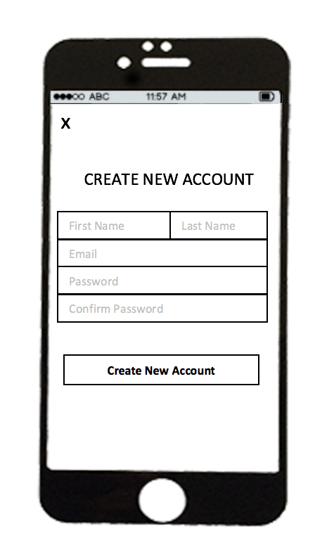

Figure 2–2 Create Account Screen

|  |  |  |  |  |  |
| --- | --- | --- | --- | --- | --- |
| No | Component Name | Required | Format | Reference | Note |
| 1 | firstNameTextField | Touch on | UITextField |  | Input Text |
| 2 | lastNameTextField | Touch on | UITextField |  | Input Text |
| 3 | emaiTextField | Touch on | UITextField |  | Input Text |
| 4 | passwordTextField | Touch on | UITextField |  | Input Text |
| 5 | confirmPasswordTextField | Touch on | UITextField |  | Input Text |
| 6 | createButton | Touch on | UIButton | Login Screen | Move to login screen |
| 7 | closeButton | Touch on | UIButton | Login Screen | Move to login screen |

## 2.1.2 Login Screen

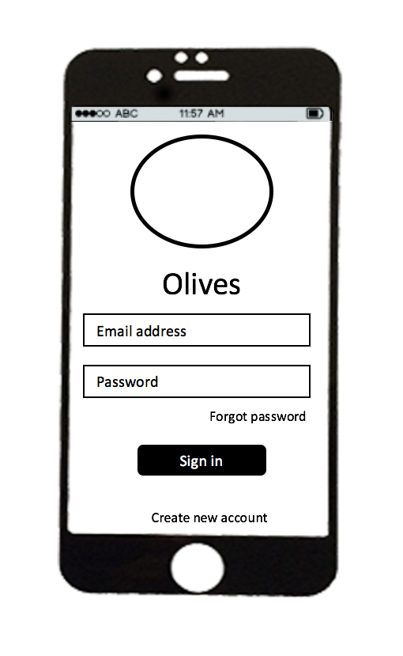

Figure 2-3 Login Screen

|  |  |  |  |  |  |
| --- | --- | --- | --- | --- | --- |
| No | Component Name | Required | Format | Reference | Note |
| 1 | emailTextField | Touch on | UITextField |  | Input Text |
| 2 | passwordTextField | Touch on | UITextField |  | Input Text |
| 3 | forgotPasswordLabel | Touch on | UILabel | Forgot Password screen | Label |
| 4 | signinButton | Touch on | UIButton | Home screen | Move to home screen |
| 5 | createAccountLabel | Touch on | UITextField | Create new account screen | Move to create new account screen |

## 2.1.3 Home Screen

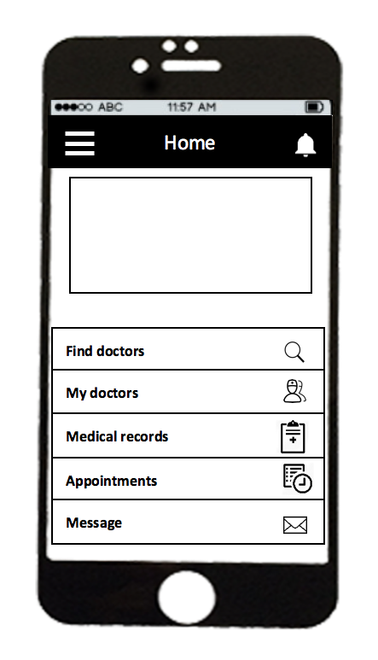

Figure 2-4 Home Screen

|  |  |  |  |  |  |
| --- | --- | --- | --- | --- | --- |
| No | Component Name | Required | Format | Reference | Note |
| 1 | findDoctorLabel | Touch on | UILabel | Find doctor screen | Move to find doctor screen |
| 2 | myDoctotLabel | Touch on | UILabel | My doctor screen | Move to my doctor screen |
| 3 | medicalLabel | Touch on | UILabel | Category screen | Move to category screen |
| 4 | appointmentLabel | Touch on | UILabel | Appointment screen | Move to appointment screen |
| 5 | messageLabel | Touch on | UILabel | Message screen | Move to message screen |
| 6 | menuButton | Touch on | UIButton | Menu screen | Move to menu screen |
| 7 | notiButton | Touch on | UIButton | Notification screen | Move to notification screen |

## 2.1.4 Menu Screen

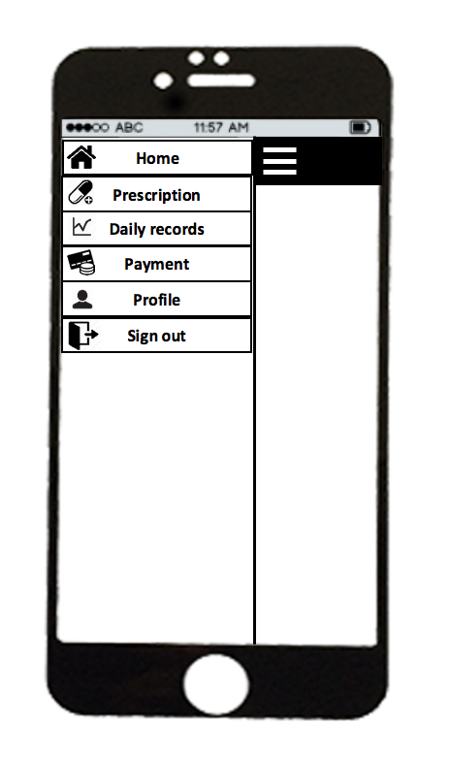

Figure 2 –5 Menu Screen

|  |  |  |  |  |  |
| --- | --- | --- | --- | --- | --- |
| No | Component Name | Required | Format | Reference | Note |
| 1 | homeLabel | Touch on | UILabel | Home screen | Move to Home screen |
| 2 | prescriptionLabel | Touch on | UILabel | Prescription screen | Move to Prescription screen |
| 3 | dailyLabel | Touch on | UILabel | Statistic screen | Move to Statistic screen |
| 4 | profileLabel | Touch on | UILabel | Profile screen | Move to profile screen |
| 5 | signoutLabel | Touch on | UILabel | Login screen | Move to login screen |

## 2.1.5 Notification Screen

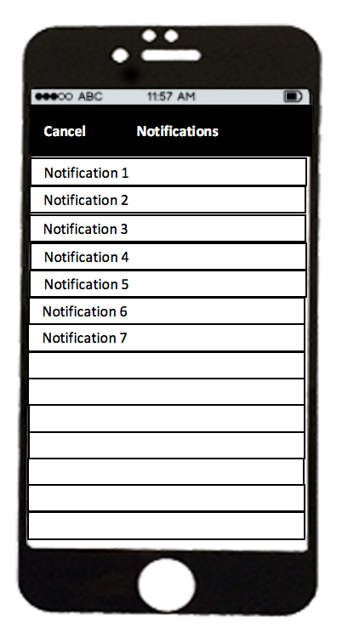

Figure 2 -6 Notification screen

|  |  |  |  |  |  |
| --- | --- | --- | --- | --- | --- |
| No | Component Name | Required | Format | Reference | Note |
| 1 | notificaitonLabel | Touch on | UILabel | Detail Screen | Move to Detail screen |
| 2 | cancelButton | Touch on | UIButton | Home Screen | Move to Home screen |

## 2.1.6 Find Doctor Screen

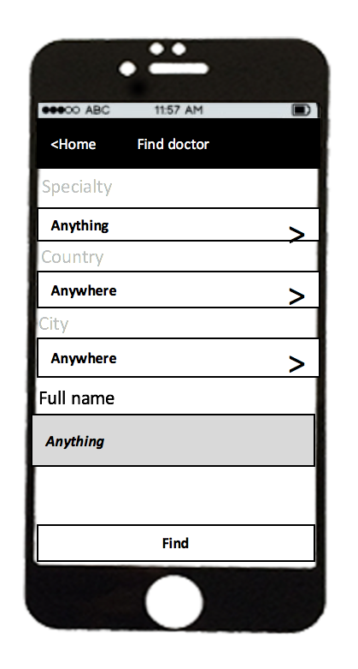

Figure 2 – 7 Find doctor screen

|  |  |  |  |  |  |
| --- | --- | --- | --- | --- | --- |
| No | Component Name | Required | Format | Reference | Note |
| 1 | specialtyLabel | Touch on | UILabel | Specialty screen | Move to Specialty screen |
| 2 | countryLabel | Touch on | UILabel | Country screen | Move to Country screen |
| 3 | cityLabel | Touch on | UILabel | City screen | Move to City screen |
| 4 | nameTextField | Touch on | UITextField |  | Input Text |
| 5 | findButton | Touch on | UIButton | Search result doctor | Move to search doctor screen |

## 2.1.7 Specialty

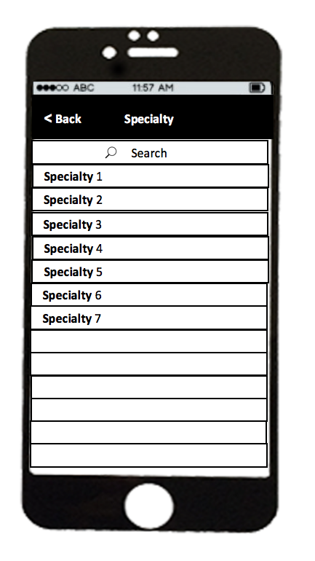

Figure 2-8 Specialty screen

|  |  |  |  |  |  |
| --- | --- | --- | --- | --- | --- |
| No | Component Name | Required | Format | Reference | Note |
| 1 | specialtyLabel | Touch on | UILabel | Find doctor screen | Move to find doctor screen |
| 2 | barSearch | Touch on | UISearchBar |  |  |
| 3 | backButton | Touch on | UIButton | Find doctor screen | Move to find doctor screen |

## 2.1.8 Country Screen

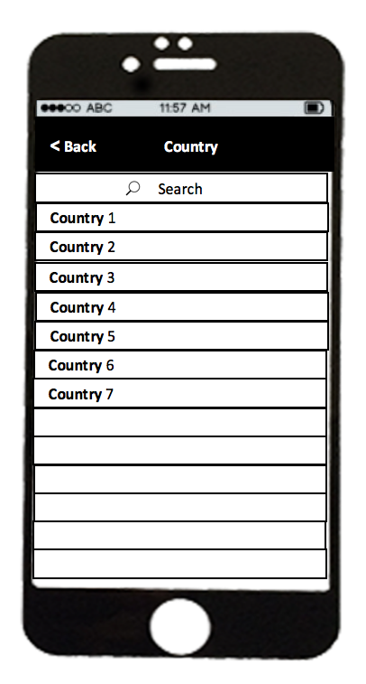

Figure 2 –9 Country Screen

|  |  |  |  |  |  |
| --- | --- | --- | --- | --- | --- |
| No | Component Name | Required | Format | Reference | Note |
| 1 | countryLabel | Touch on | UILabel | Find doctor screen | Move to find doctor screen |
| 2 | barSearch | Touch on | UISearchBar |  |  |
| 3 | backButton | Touch on | UIButton | Find doctor screen | Move to find doctor screen |

## 2.1.9 City Screen

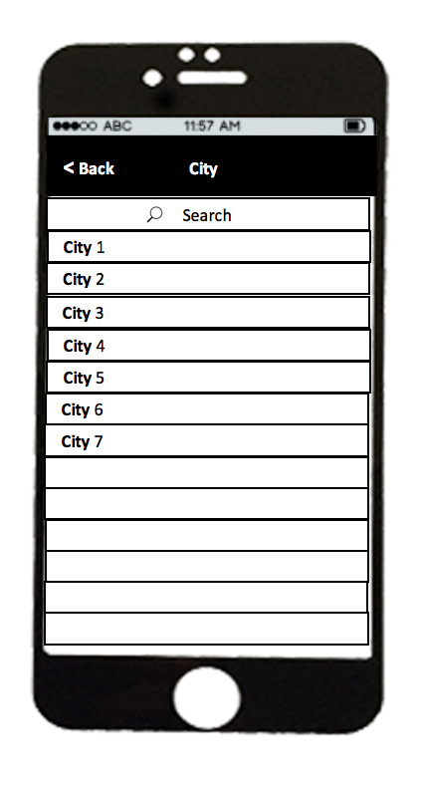

Figure 2-10 City Screen

|  |  |  |  |  |  |
| --- | --- | --- | --- | --- | --- |
| No | Component Name | Required | Format | Reference | Note |
| 1 | cityLabel | Touch on | UILabel | Find doctor screen | Move to find doctor screen |
| 2 | barSearch | Touch on | UISearchBar |  |  |
| 3 | backButton | Touch on | UIButton | Find doctor screen | Move to find doctor screen |

## 2.1.10 My Doctor Screen

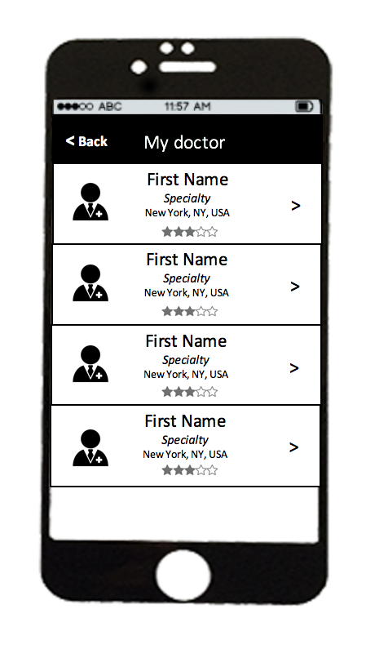

Figure 2-11 My doctor Screen

|  |  |  |  |  |  |
| --- | --- | --- | --- | --- | --- |
| No | Component Name | Required | Format | Reference | Note |
| 1 | doctorTableCell | Touch on | UITableViewCell | Profile doctor screen | Move to profile doctor screen |
| 2 | backButton | Touch on | UIButton | Home screen | Move to Home screen |

## 2.1.11 Doctor Profile

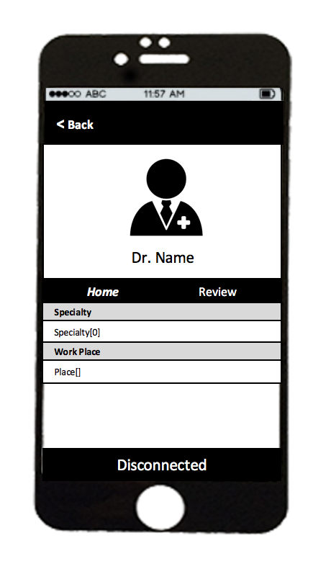

Figure 2-12 Profile Doctor

|  |  |  |  |  |  |
| --- | --- | --- | --- | --- | --- |
| No | Component Name | Required | Format | Reference | Note |
| 1 | specialtyLabel |  | UILabel |  | Label |
| 2 | workplaceLabel |  | UILabel |  | Label |
| 3 | disconnectButton | Touch on | UIButton | Alert Confirm | AlertView |
| 4 | backButton | Touch on | UIButton | Search doctor Screen | Move to search doctor screen |

## 2.1.12 Review Screen

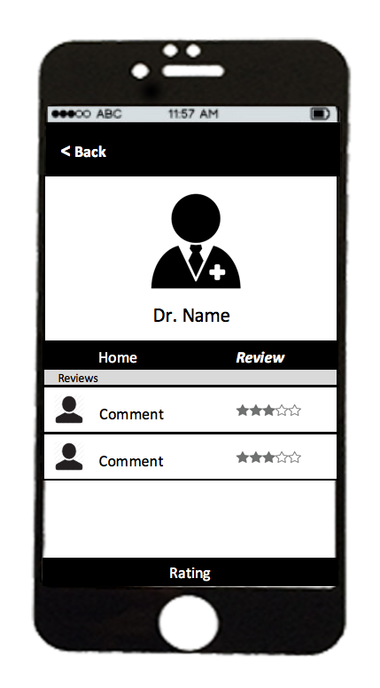

Figure 2-0‑13 Review Screen

|  |  |  |  |  |  |
| --- | --- | --- | --- | --- | --- |
| No | Component Name | Required | Format | Reference | Note |
| 1 | commentLabel |  | UILabel |  | Label |
| 2 | rateView |  | UiView |  | View |
| 3 | backButton | Touch on | UIButton | Find doctor screen | Move to find doctor screen |

## 2.1.13 Rating Screen

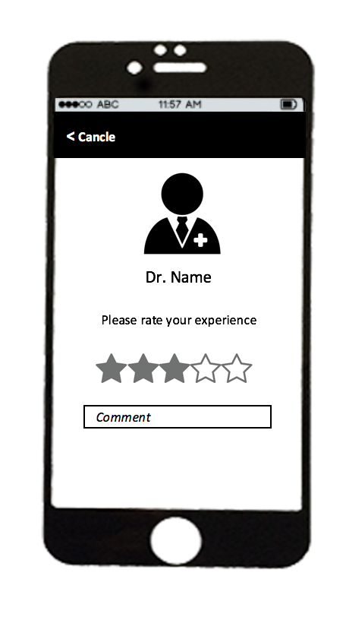

Figure 2-14 Rating Screen

|  |  |  |  |  |  |
| --- | --- | --- | --- | --- | --- |
| No | Component Name | Required | Format | Reference | Note |
| 1 | avatarImageView |  | UIImageView |  | Image |
| 2 | nameLabel |  | UILabel |  | Label |
| 3 | backButton | Touch on | UIButton | Find doctor screen | Move to search doctor screen |
| 4 | rateView | Touch on | UIView |  | View |
| 5 | commentTextField | Touch on | UITexField |  | Input Text |

## 2.1.14 Appointment Screen

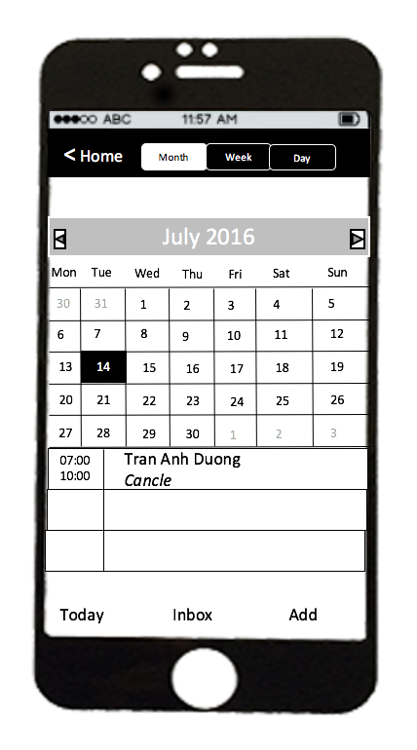

Figure 2-14 Appointment Screen

|  |  |  |  |  |  |
| --- | --- | --- | --- | --- | --- |
| No | Component Name | Required | Format | Reference | Note |
| 1 | segment | Touch on | UISegment |  | Select mode segment |
| 2 | calendarView | Touch on |  |  |  |
| 3 | backButton | Touch on | UIButton | Find doctor screen | Move to find doctor screen |
| 4 | eventTableCell | Touch on | UITableViewCell | Detail Appointment screen | Move to detail appointment screen |
| 5 | todayButton | Touch on | UIButton |  | Go today on calendar view |
| 6 | inboxButton | Touch on | UIButton | Inbox Screen | Move to inbox screen |
| 7 | addButton | Touch on | UIButton | Create appointment screen | Move to create appointment screen |

2.1.15 Detail appoinment

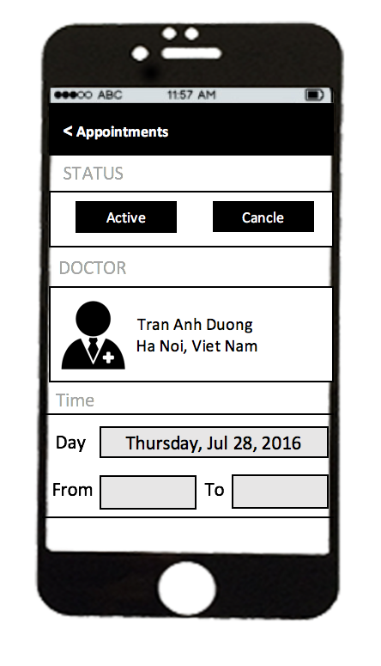

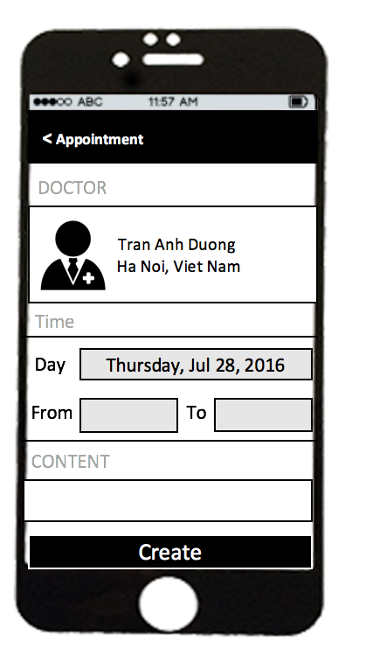

Figure 0‑2-16 Deatil Appontment

|  |  |  |  |  |  |
| --- | --- | --- | --- | --- | --- |
| No | Component Name | Required | Format | Reference | Note |
| 1 | statusButton | Touch on | UIButton |  | Button |
| 2 | cancelButton | Touch on | UIButton | AlertConfirm | Confirm cancel appoinemtn |
| 3 | doctorUITableCell | Touch on | UITableViewCell | Profile Doctor screen | Move profile doctor screen |
| 4 | backButton | Touch on | UIButton | Appointment screen | Move to appointment screen |
| 5 | dayTextField | Touch on | UITextField |  | Select day |
| 6 | fromTextField | Touch on | UITextField |  | Select from time |
| 7 | toTextField | Touch on | UITextField |  | Select to time |
| 8 | contentTextView | Touch on | UITextView |  | Input text |
| 9 | createButton | Touch on | UIButton |  | Action create appointment |

## 2.1.16 Inbox Appoinment Screen

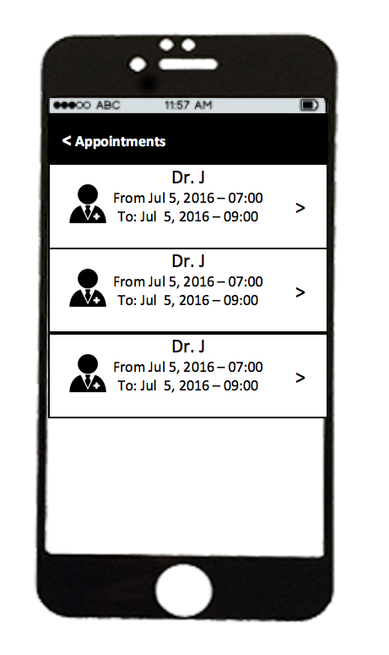

Figure 2-17 Inbox appointment screen

|  |  |  |  |  |  |
| --- | --- | --- | --- | --- | --- |
| No | Component Name | Required | Format | Reference | Note |
| 1 | appointmentCell | Touch on | UITableViewCell | Detail Appointment screen | Move to appointment screen |
| 2 | fromLabel |  | UILabel |  | Display from time appointment |
| 3 | toLabel |  | UILabel |  | Display to time appointment |
| 3 | backButton | Touch on | UIButton | Find doctor screen | Move to find doctor screen |

## 2.1.17 Prescription Screen

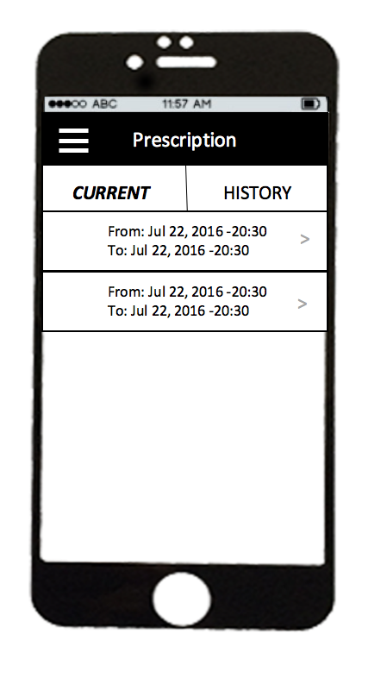

Figure 2-18 Prescription Screen

|  |  |  |  |  |  |
| --- | --- | --- | --- | --- | --- |
| No | Component Name | Required | Format | Reference | Note |
| 1 | menuButton | Touch on | UIButton | Menu screen | Move to menu screen |
| 2 | currentButton | Touch on | UIButton |  | Show current prescription |
| 3 | historyButton | Touch on | UIButton |  | Show history prescription |
| 4 | prescriptionCell | Touch on | UITableViewCell | Detail prescription screen | Move to prescription screen |

## 2.1.18 Detail Prescription Screen

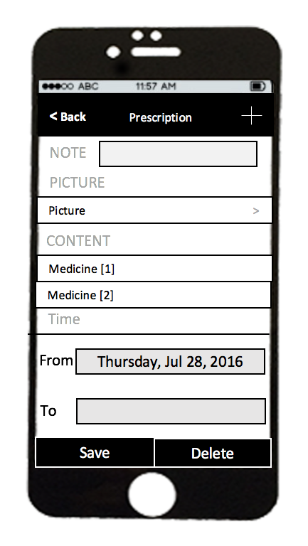

Figure2-19 Detail Prescription screen

|  |  |  |  |  |  |
| --- | --- | --- | --- | --- | --- |
| No | Component Name | Required | Format | Reference | Note |
| 1 | noteTextView | Touch on | UITextView |  | Input Text |
| 2 | pictureCell | Touch on | UItableViewCell | List Image screen | Move to List image Screen |
| 3 | medicineCell | Touch on | UITableViewCell | Medicine screen | Move to Medicine Screen |
| 4 | fromTextField | Touch on | UITextField |  | Select date time |
| 5 | toTextField | Touch on | UITextField |  | Select date time |
| 6 | saveButton | Touch on | UIButton |  | Action save in formation prescription |
| 7 | deleteButton | Touch on | UIButton |  | Action delete prescription |
| 8 | addButton | Touch on | UIbarButtonItem | Add Medicine Screen | Move to Medicine Screen |
| 9 | backButton | Touch on | UIButton | Find doctor screen | Move to list Prescription screen |

## 2.1.19 Create Prescription

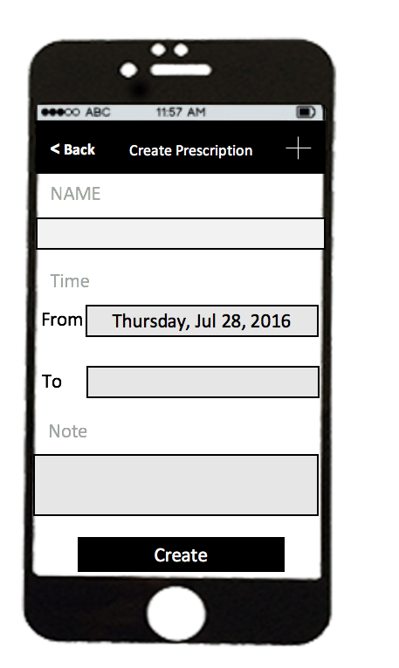

Figure 2-20 Create Prescription

|  |  |  |  |  |  |
| --- | --- | --- | --- | --- | --- |
| No | Component Name | Required | Format | Reference | Note |
| 1 | nameTextField | Touch on | UITextField |  | Input Text |
| 2 | noteTextView | Touch on | UITextView |  | Input Text |
| 4 | fromTextField | Touch on | UITextField |  | Select date time |
| 5 | toTextField | Touch on | UITextField |  | Select date time |
| 6 | createButton | Touch on | UIButton |  | Action save in formation prescription |
| 7 | addButton | Touch on | UIbarButtonItem | Add Medicine Screen | Move to Medicine Screen |
| 8 | backButton | Touch on | UIButton | Find doctor screen | Move to List Prescription screen |

## 2.1.20 Image Prescription Screen

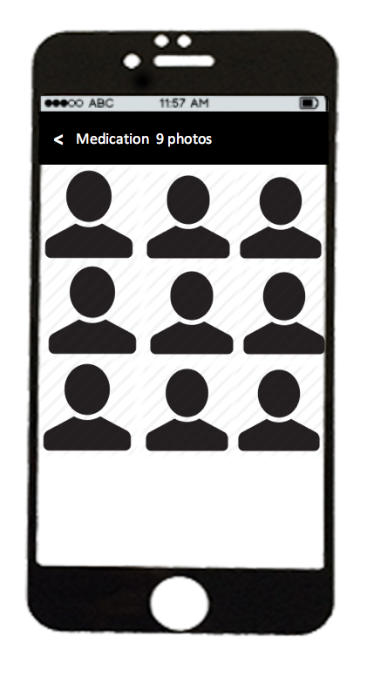

Figure 2-21 Image prescription screen

|  |  |  |  |  |  |
| --- | --- | --- | --- | --- | --- |
| No | Component Name | Required | Format | Reference | Note |
| 1 | imageView | Touch on | UIimageView |  | Show Image |
| 3 | backButton | Touch on | UIButton | Find doctor screen | Move to prescription screen |

## 2.1.21 Medicine Screen

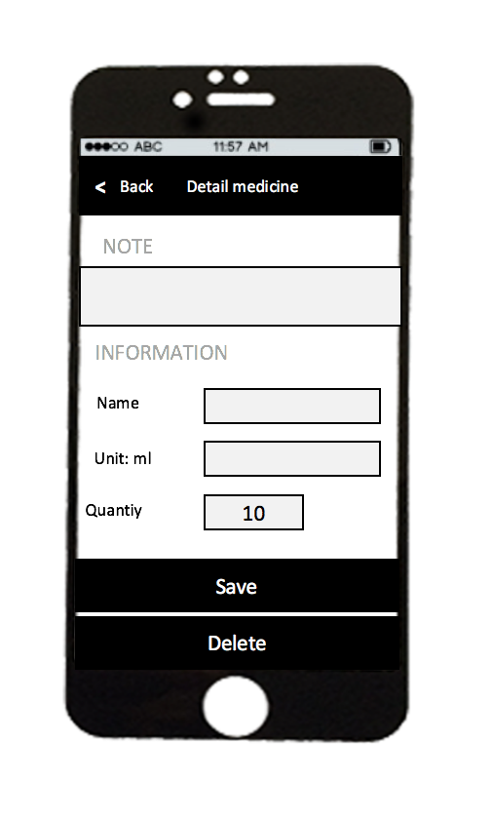

Figure 2-22 Medcine Screen

|  |  |  |  |  |  |
| --- | --- | --- | --- | --- | --- |
| No | Component Name | Required | Format | Reference | Note |
| 1 | noteTextView | Touch on | UITextView |  | Input Text |
| 2 | quantityTextField | Touch on | UITextField |  | Input Text |
| 3 | unitTextField | Touch on | UItextField |  | Input Text |
| 4 | deleteButton | Touch on | UIButton |  | Action delete prescription |
| 5 | saveButton | Touch on | UIButton |  | Action save prescription |
| 6 | backButton | Touch on | UIButton | Find doctor screen | Move to Prescription screen |

## 2.1.21 Add Medicine Screen

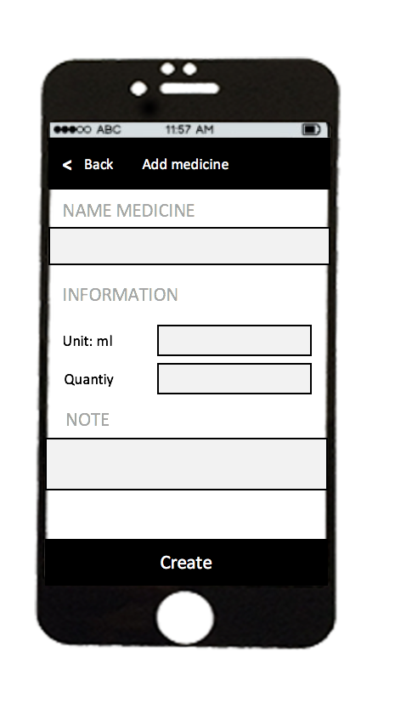

Figure 2-22 Add medicine screen

|  |  |  |  |  |  |
| --- | --- | --- | --- | --- | --- |
| No | Component Name | Required | Format | Reference | Note |
| 1 | noteTextView | Touch on | UITextView |  | Input Text |
| 2 | quantityTextField | Touch on | UITextField |  | Input Text |
| 3 | unitTextField | Touch on | UItextField |  | Input Text |
| 4 | deleteButton | Touch on | UIButton |  | Action delete prescription |
| 5 | backButton | Touch on | UIButton | Find doctor screen | Move to Prescription screen |
| 6 | nameTextField | Touch on | UITextField |  | Input Text |

## 2.1.22 Statistic Stats Screen

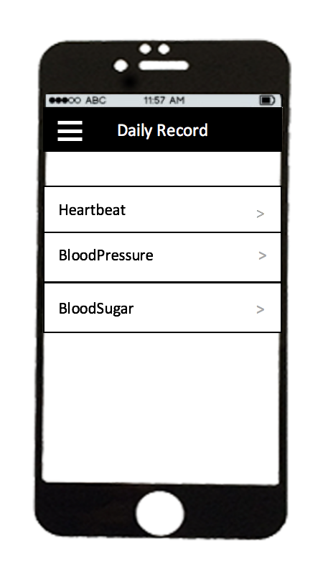

Figure 2-23 Statistic stats screen

|  |  |  |  |  |  |
| --- | --- | --- | --- | --- | --- |
| No | Component Name | Required | Format | Reference | Note |
| 1 | menuButton | Touch on | UITextView | Menu screen | Move to menu screen |
| 2 | recordTextField | Touch on | UItextField | Detail Record screen | Move to Detail Record screen |

## 2.1.23 Heartbeat Screen

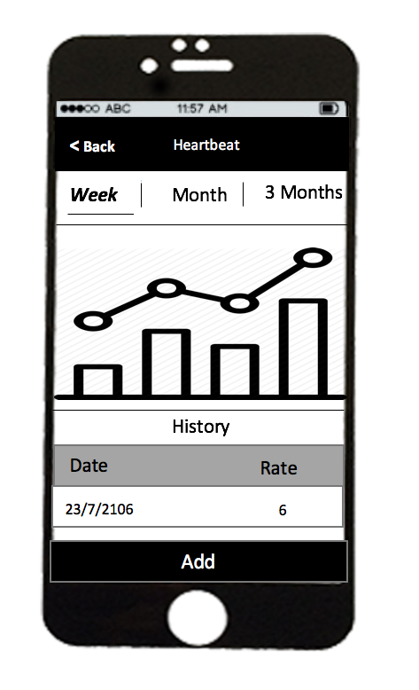

Figure 2-23 Heartbeat screen

|  |  |  |  |  |  |
| --- | --- | --- | --- | --- | --- |
| No | Component Name | Required | Format | Reference | Note |
| 1 | modeSegment | Touch on | UISegment |  | Select mode view heartbeat |
| 2 | unitTextField | Touch on | UItextField |  | Input Text |
| 3 | addButton | Touch on | UIButton | Heartbeat screen | Move to Create Heartbeat screen |
| 4 | chartView | Touch on | UIView |  | Show statistic of heartbeat |
| 5 | backButton | Touch on | UIButton | Menu screen | Move to menu screen |

## 2.1.24 Edit Heartbeat

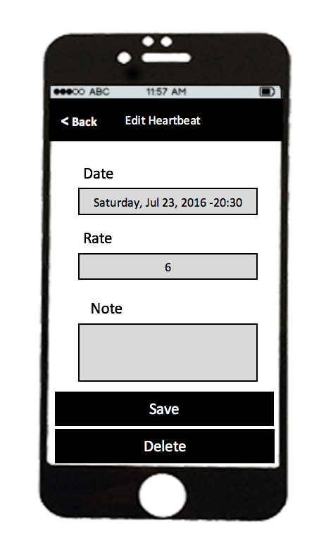

Figure 2-25 Edit Heartbeat Screen

|  |  |  |  |  |  |
| --- | --- | --- | --- | --- | --- |
| No | Component Name | Required | Format | Reference | Note |
| 1 | dateTextField | Touch on | UITextField |  | Select date time |
| 2 | rateTextField | Touch on | UITextField |  | Input number |
| 3 | noteTextView | Touch on | UITextView |  | Input Text |
| 4 | saveButton | Touch on | UIButton |  | Action save heartbeat record |
| 5 | deleteButton | Touch on | UIButton |  | Action delete heartbeat record |
| 6 | backButton | Touch on | UIButton | Find doctor screen | Move to Prescription screen |

## 2.1.25 Add Heartbeat Screen

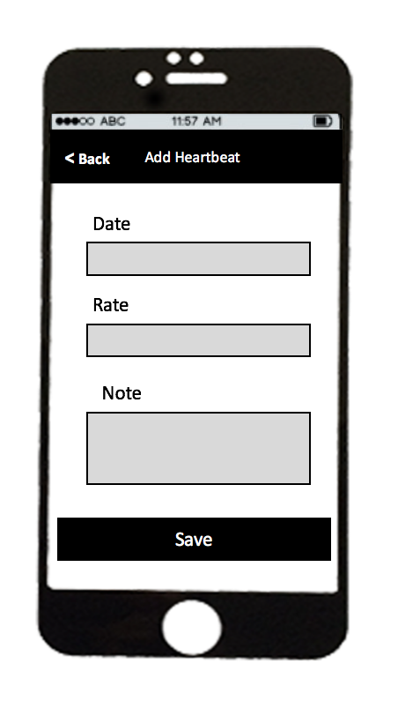

Figure 2-26 Add Heartbeat screen

|  |  |  |  |  |  |
| --- | --- | --- | --- | --- | --- |
| No | Component Name | Required | Format | Reference | Note |
| 1 | dateTextField | Touch on | UITextField |  | Select date time |
| 2 | rateTextField | Touch on | UITextField |  | Input number |
| 3 | noteTextView | Touch on | UITextView |  | Input Text |
| 4 | saveButton | Touch on | UIButton |  | Action save heartbeat record |
| 5 | backButton | Touch on | UIButton | Find doctor screen | Move to Heartbeat screen |

## 2.1.26 Blood Pressure Screen

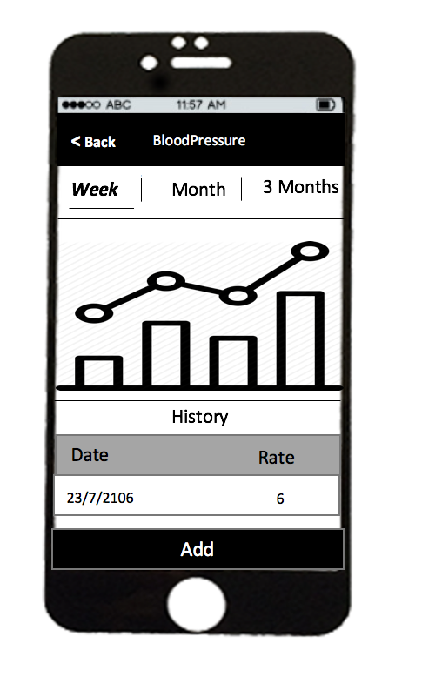

Figure 2-27 Blood Pressure screen

|  |  |  |  |  |  |
| --- | --- | --- | --- | --- | --- |
| No | Component Name | Required | Format | Reference | Note |
| 1 | modeSegment | Touch on | UISegment |  | Select mode view blood pressure |
| 2 | unitTextField | Touch on | UItextField |  | Input Text |
| 3 | addButton | Touch on | UIButton | Heartbeat screen | Move to Create Blood Pressure screen |
| 4 | chartView |  | UIView |  | Show statistic of blood pressure |
| 5 | backButton | Touch on | UIButton | Menu screen | Move to Statistic screen |

## 2.1.27 Edit Blood Pressure

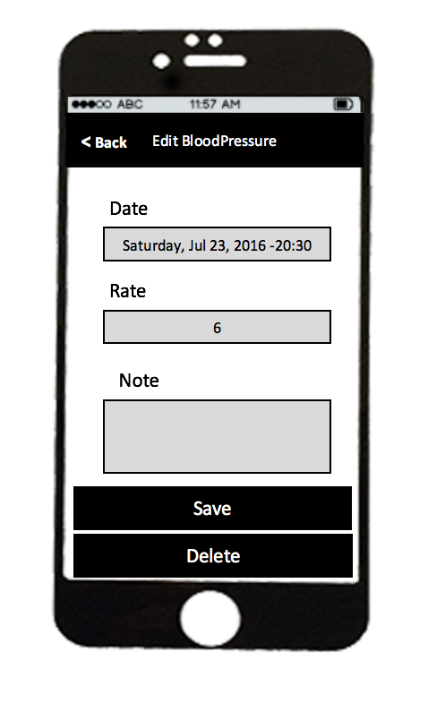

Figure 2-27 Edit Blood Pressure Screen

|  |  |  |  |  |  |
| --- | --- | --- | --- | --- | --- |
| No | Component Name | Required | Format | Reference | Note |
| 1 | dateTextField | Touch on | UITextField |  | Select date time |
| 2 | rateTextField | Touch on | UITextField |  | Input number |
| 3 | noteTextView | Touch on | UITextView |  | Input Text |
| 4 | saveButton | Touch on | UIButton |  | Action save blood pressure record |
| 5 | deleteButton | Touch on | UIButton |  | Action delete blood pressure record |
| 6 | backButton | Touch on | UIButton | Find doctor screen | Move to Blood Pressure screen |

## 2.1.28 Add Blood Pressure

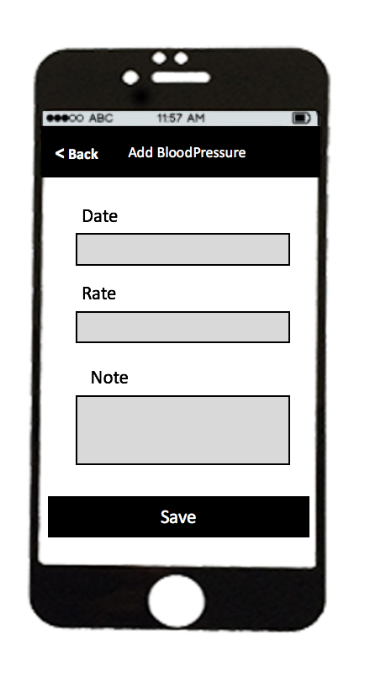

Figure 2-29 Add Blood Pressure

|  |  |  |  |  |  |
| --- | --- | --- | --- | --- | --- |
| No | Component Name | Required | Format | Reference | Note |
| 1 | dateTextField | Touch on | UITextField |  | Select date time |
| 2 | rateTextField | Touch on | UITextField |  | Input number |
| 3 | noteTextView | Touch on | UITextView |  | Input Text |
| 4 | saveButton | Touch on | UIButton |  | Action save blood pressure record |
| 5 | backButton | Touch on | UIButton | Find doctor screen | Move to Blood Pressure screen |

2.1.29 Blood Sugar Screen

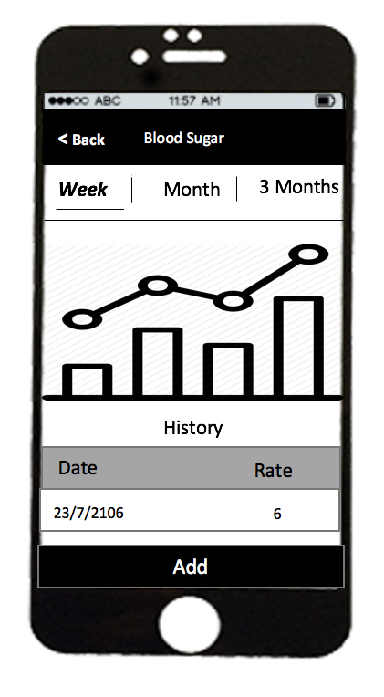

Figure 2-30 Blood Sugar Screen

|  |  |  |  |  |  |
| --- | --- | --- | --- | --- | --- |
| No | Component Name | Required | Format | Reference | Note |
| 1 | modeSegment | Touch on | UISegment |  | Select mode view blood sugar |
| 2 | unitTextField | Touch on | UItextField |  | Input Text |
| 3 | addButton | Touch on | UIButton | Heartbeat screen | Move to Create Blood Sugar screen |
| 4 | chartView |  | UIview |  | Show statistic of blood sugar |
| 5 | backButton | Touch on | UIButton | Menu screen | Move to Statistic screen |

## 2.1.30 Edit Blood Sugar Screen

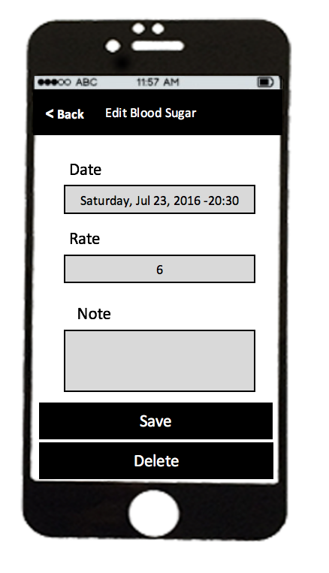

Figure 2-31 Edit Blood Sugar Screen

|  |  |  |  |  |  |
| --- | --- | --- | --- | --- | --- |
| No | Component Name | Required | Format | Reference | Note |
| 1 | dateTextField | Touch on | UITextField |  | Select date time |
| 2 | rateTextField | Touch on | UITextField |  | Input number |
| 3 | noteTextView | Touch on | UITextView |  | Input Text |
| 4 | saveButton | Touch on | UIButton |  | Action save blood sugar record |
| 5 | deleteButton | Touch on | UIButton |  | Action delete blood sugar record |
| 6 | backButton | Touch on | UIButton | Find doctor screen | Move to Blood Sugar screen |

## 2.1.31 Add Blood Sugar Screen

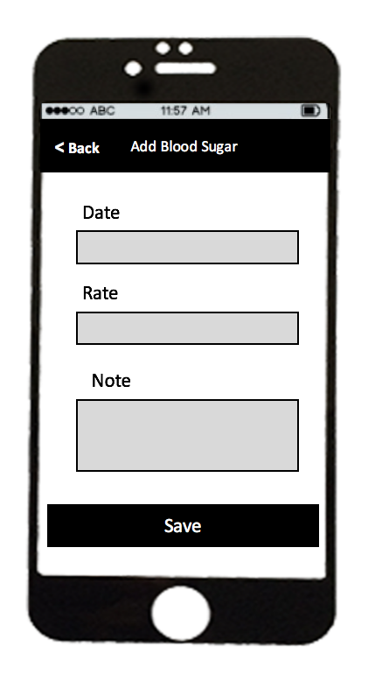

Figure 2-0‑31 Add Blood Sugar Screen

|  |  |  |  |  |  |
| --- | --- | --- | --- | --- | --- |
| No | Component Name | Required | Format | Reference | Note |
| 1 | dateTextField | Touch on | UITextField |  | Select date time |
| 2 | rateTextField | Touch on | UITextField |  | Input number |
| 3 | noteTextView | Touch on | UITextView |  | Input Text |
| 4 | saveButton | Touch on | UIButton |  | Action save blood sugar record |
| 5 | backButton | Touch on | UIButton | Find doctor screen | Move to Blood Sugar screen |

2.1.32 Profile Screen

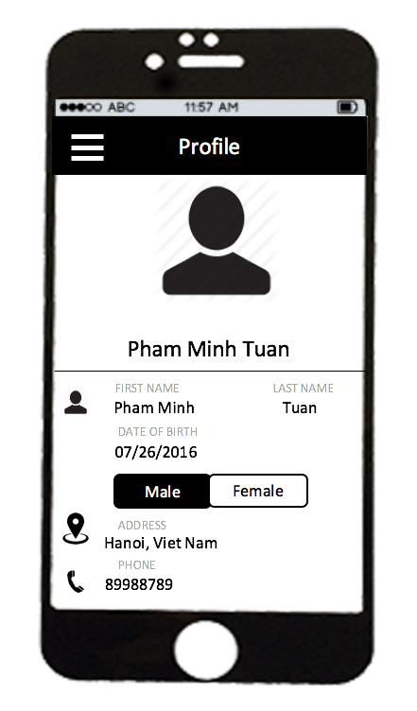

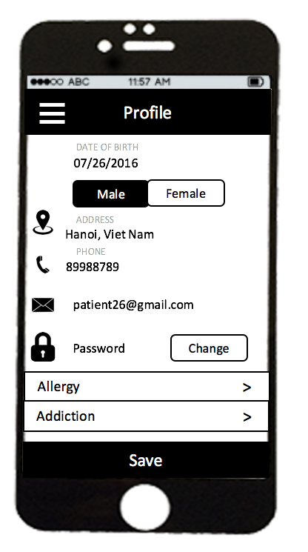

Figure 2-33 Profile Screen

|  |  |  |  |  |  |
| --- | --- | --- | --- | --- | --- |
| No | Component Name | Required | Format | Reference | Note |
| 1 | avatarImageView | Touch on | UIImageView |  | Update avatar |
| 2 | firstNameTextField | Touch on | UITextField |  | Input text |
| 3 | lastNameTextField | Touch on | UITextField |  | Input text |
| 4 | dateOfBirthTextField | Touch on | UITextField |  | Select date time |
| 5 | genderSegment | Touch on | UISegment |  | Select gender |
| 6 | addressTextField | Touch on | UITextField |  | Input Text |
| 7 | phoneTextField | Touch on | UITextField |  | Input Text |
| 8 | emailLabel |  | UiLabel |  | Label |
| 9 | changeButton | Touch on | UIButton | Change password screen | Move to Change Password Screen |
| 10 | allergryTextField | Touch on | UILabel | Allergy screen | Move to Allergy screen |
| 11 | addictionTextField | Touch on | UILabel | Addiction screen | Move to Addiction screen |
| 5 | backButton | Touch on | UIButton | Find doctor screen | Move to Blood Sugar screen |

## 2.1.33 Change Password Screen

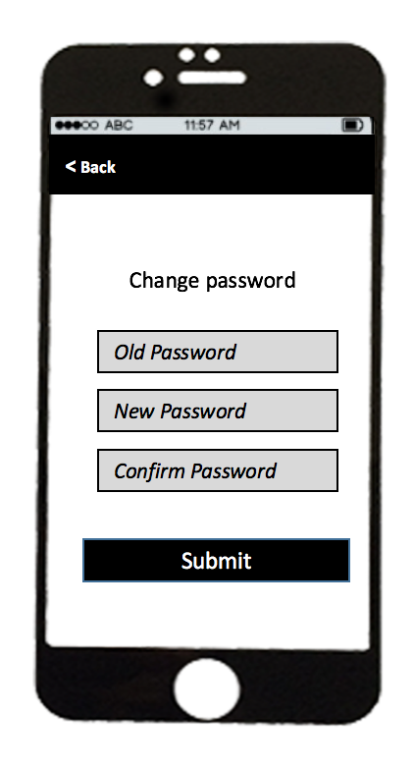

Figure 2‑34 Change Password Screen

|  |  |  |  |  |  |
| --- | --- | --- | --- | --- | --- |
| No | Component Name | Required | Format | Reference | Note |
| 1 | oldPasswordTextFiled | Touch on | UITextField |  | Input text |
| 2 | newPasswordTextField | Touch on | UITextField |  | Input text |
| 3 | confirmTextField | Touch on | UITextView |  | Input text |
| 4 | submitButton | Touch on | UIButton |  | Action change password |
| 5 | backButton | Touch on | UIButton | Profile screen | Move to Profile screen |

## 2.1.34 Allergy Screen

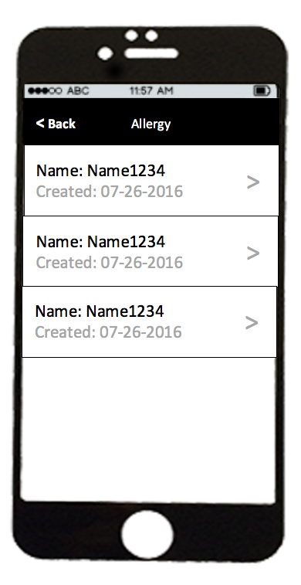

Figure 2‑30‑4 Allergy Screen

|  |  |  |  |  |  |
| --- | --- | --- | --- | --- | --- |
| No | Component Name | Required | Format | Reference | Note |
| 1 | nameLabel |  | UILabel |  | Display name allergy |
| 2 | createLabel |  | UILabel |  | Display date time |
| 3 | allergyCell | Touch on | UITableViewCell | Detail Allergy screen | Move to Detail Allergy screen |
| 4 | backButton | Touch on | UIButton | Profile screen | Move to Profile screen |

## 2.1.35 Detail Allergy Screen

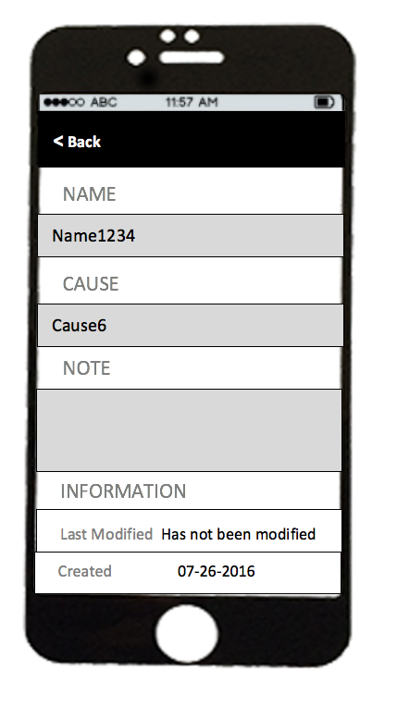

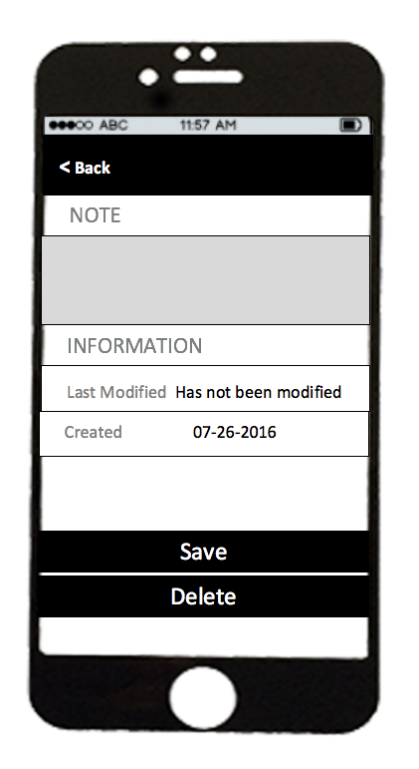

Figure 2–36 Detail Allergy Screen

|  |  |  |  |  |  |
| --- | --- | --- | --- | --- | --- |
| No | Component Name | Required | Format | Reference | Note |
| 1 | nameTextField |  | UITextField |  | Input text |
| 2 | causeTextField |  | UiTextField |  | Input text |
| 3 | noteTextView | Touch on | UITextView |  | Input text |
| 4 | saveButton | Touch on | UIButton |  | Action save information of allergy |
| 5 | deleteButton | Touch on | UIButton |  | Action delete allergy record |
| 6 | backButton | Touch on | UIButton | Profile screen | Move to Profile screen |

## 2.1.36 Addiction Screen

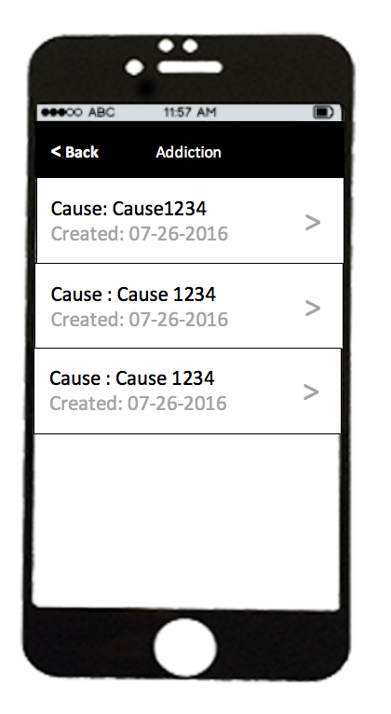

Figure 2‑37 Addiction Screen

|  |  |  |  |  |  |
| --- | --- | --- | --- | --- | --- |
| No | Component Name | Required | Format | Reference | Note |
| 1 | nameLabel |  | UILabel |  | Display name addiction |
| 2 | createLabel |  | UILabel |  | Display date time |
| 3 | addictionCell | Touch on | UITableViewCell | Detail Addiction screen | Move to Detail Addiction screen |
| 4 | backButton | Touch on | UIButton | Profile screen | Move to Profile screen |

## 2.1.37 Detail Addiction

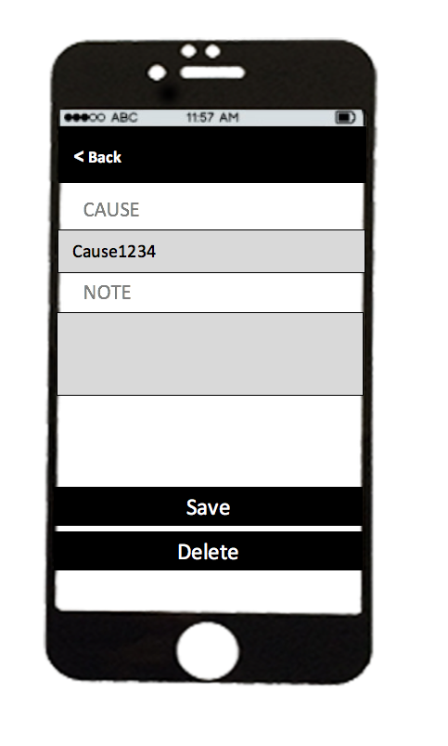

Figure 2‑38 Detail Addiction Screen

|  |  |  |  |  |  |
| --- | --- | --- | --- | --- | --- |
| No | Component Name | Required | Format | Reference | Note |
| 1 | nameTextField |  | UITextField |  | Input text |
| 2 | causeTextField |  | UiTextField |  | Input text |
| 3 | noteTextView | Touch on | UITextView |  | Input text |
| 4 | saveButton | Touch on | UIButton |  | Action save information of addiction |
| 5 | deleteButton | Touch on | UIButton |  | Action delete addiction record |
| 6 | backButton | Touch on | UIButton | Profile screen | Move to Profile screen |